**Correction and Review Request - 4 (12-01-2022)**

Hi Team,

Wishing all team members and their family to have a **HAPPY, HEALTHY & PROSPEROUS NEW YAER 2022.**

First of all, I’d like to **THANK YOU ALL** for the awesome job you have done so far. I’m happy that I’m working with talented professional team and really pound of you all  
  
**WELL DONE!**

**Correction and Review 1**

MEDICAL TREATMENT Page (<https://cdh.deviotech.com/medical/treatments>)

I really like the layout and the turning image you have integrated. I LOVE IT.

Please make the image size smaller and put **5 treatment images in one line** and keep **only 4 lines total.** So, remove below treatment images

1. Umbilical Hernia Repair
2. Hearing Screening Test

Below the 4 lines of the treatment images

**Click the below word document** and please put our treatment list attached here

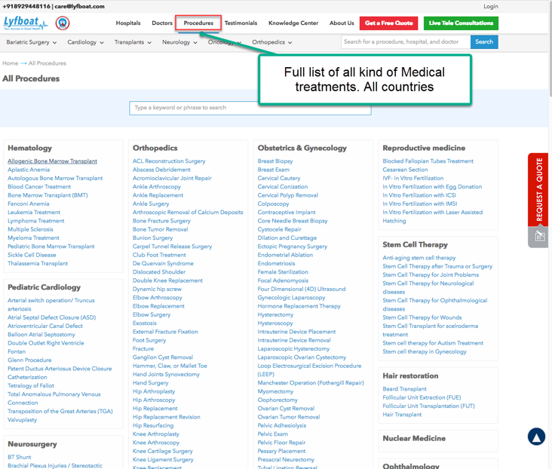

Please check below 2 competitors link

<https://www.lyfboat.com/procedures/>

<https://www.health-tourism.com/specialties-list/>

**Correction and Review 2**

MEDICAL ARTICAL Page (<https://cdh.deviotech.com/medical-articles>)

WE only publish articles that are written. We can have 6 articles per page and articles category on the left side. **Can you do a very good layout better than in the below screenshot** from below link??

<https://www.lyfboat.com/knowledge-center/>

We can HAVE THE SAME rotating image style or different. I DON’T WANT TO COPY THE SAME LAYOUT.

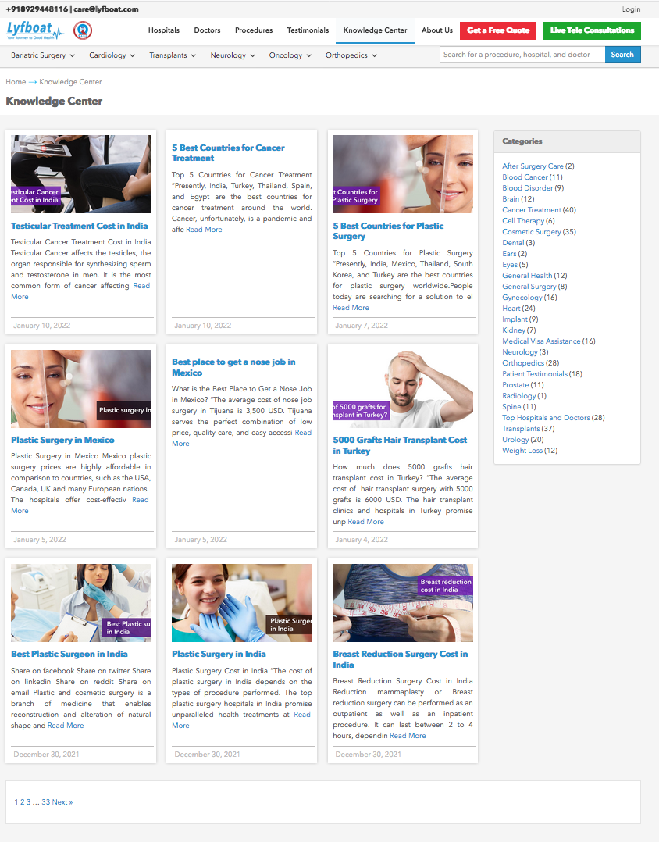

When they click the article it should display the article like below link

<https://www.lyfboat.com/testicular-cancer-treatment-cost-in-india/>

Click the word document for our new article



I also attached the 2 medical images should be publish separately

**Correction and Review 3**

MEDICAL TOURISM GUIDE Page (<https://cdh.deviotech.com/medical/tourism-guide>)

Shall we make the layout similar to below link? OR **YOU CAN SUGGEST ME GOOD BETTER LAYOUT**

<https://www.health-tourism.com/medical-tourism/benefits/>

Click the word document for our new content for this page



**Correction and Review 4**

POPULAR DESTINATION Page (<https://cdh.deviotech.com/popular-destination>)

Shall we make the layout similar to below link? OR **YOU CAN SUGGEST ME GOOD BETTER LAYOUT**

<https://www.health-tourism.com/destinations/>

Click the word document for our new content for this page



Left side country listing **(PLEASE PUT IN THE ALPHABETICAL ORDER WITH COUNTRY FLAG**)

**ASIA**

India

Malaysia

Philippines

Singapore

Thailand

**EUROPE**

United Kingdom

France

Poland

Spain

Turkey

**LATIN AMERICA**

Argentina

Brazil

Mexico

**Correction and Review 5**

About Us Page (<https://cdh.deviotech.com/about-us>)

Click the word document for our new content for this page



**Correction and Review 6**

Prices Page (<https://cdh.deviotech.com/compare-prices>)

IMPORTANT NOTE: **Change the url name to** https://cdh.deviotech.com/prices

**THIS IS NOT COMPARE PRICE PAGE**

Click the word document for our new content for this page



**Correction and Review 7**

Patient Services Page (<https://cdh.deviotech.com/compare-prices>)

IMPORTANT NOTE: **Change the url name to** https://cdh.deviotech.com/patient-services

Click the word document for our new content for this page



**LANDING PAGE CORRECTIONS**

**Correction 8**



+44 7 538 598 550

Compare Prices

Our mobile number is GOLDEN NUMBER easy to remember, please put this number same as I’ve written here and with WhatsApp logo in front mobile number

**Correction 9**

Please create **Contact Us** page anywhere. I prefer next to Popular destination if we have space (ONLY IN 1 PLACE)



Contact Us

We can use our template page

http://ansonika.com/panagea/contacts.html

Click the word document for our new content for this page



**Correction 10**

I prefer to use below link language tool plug-in

<https://www.languagewire.com/en/technology/platform>



I need below list of languages

Chinese

Thai

English

French

Spanish

Portuguese

Deutsch (German)

Arabic

**Correction 11**



Please correct the menu separation bar issue

**Correction 12**

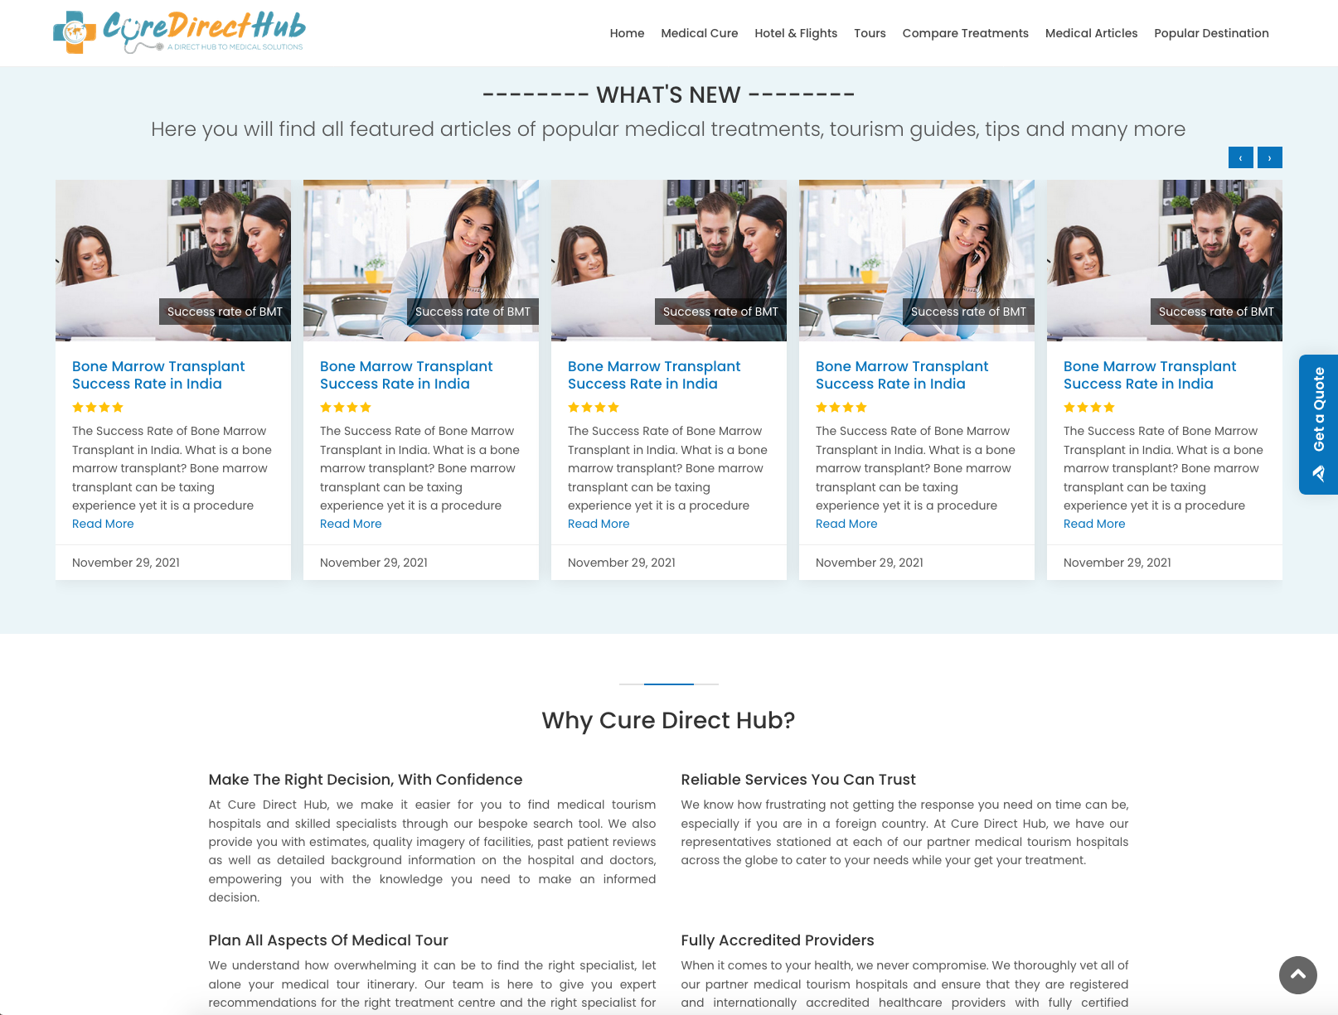

Please correct the left and right text alignments

Continue Next page…

**Correction 13**

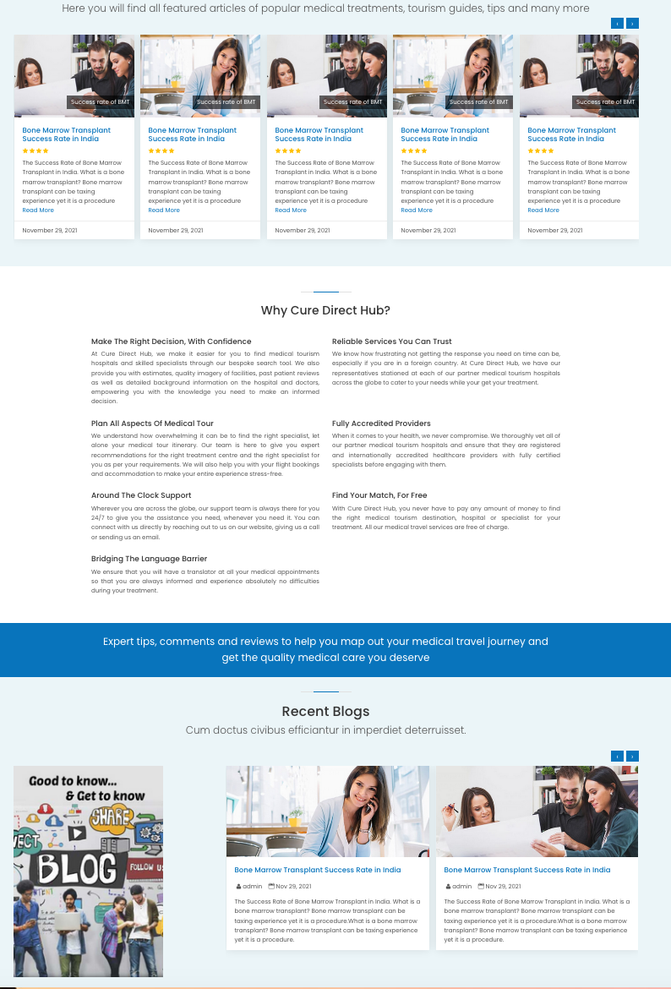



I prefer to keep the same as 5 boxes. layout for blog post. This will be the same width.

1st box for this Image

4 boxes for blog post

**Correction 14**

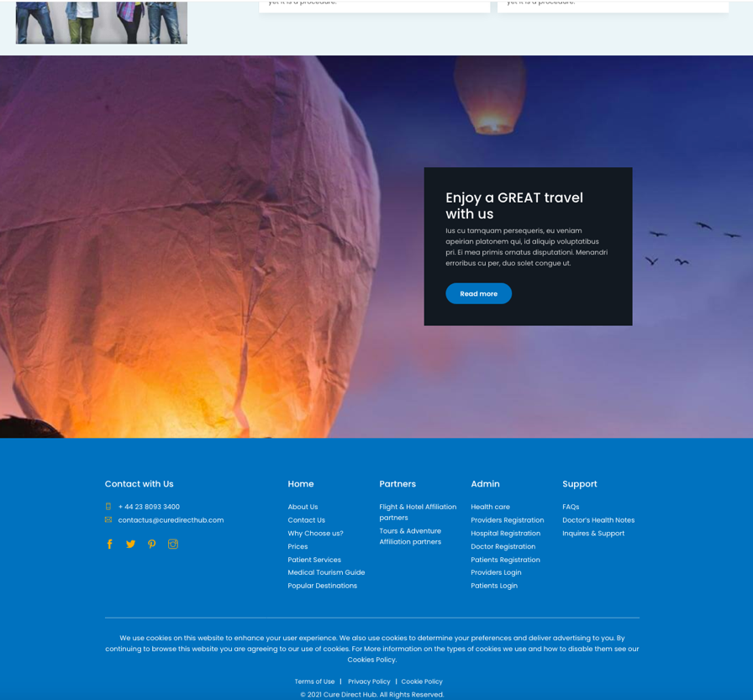

Please correct the left and right alignments

Please put below text

Why Cure Direct Hub?

+44 7 538 598 550

**Correction 15**

Please correct the size of the advert banner

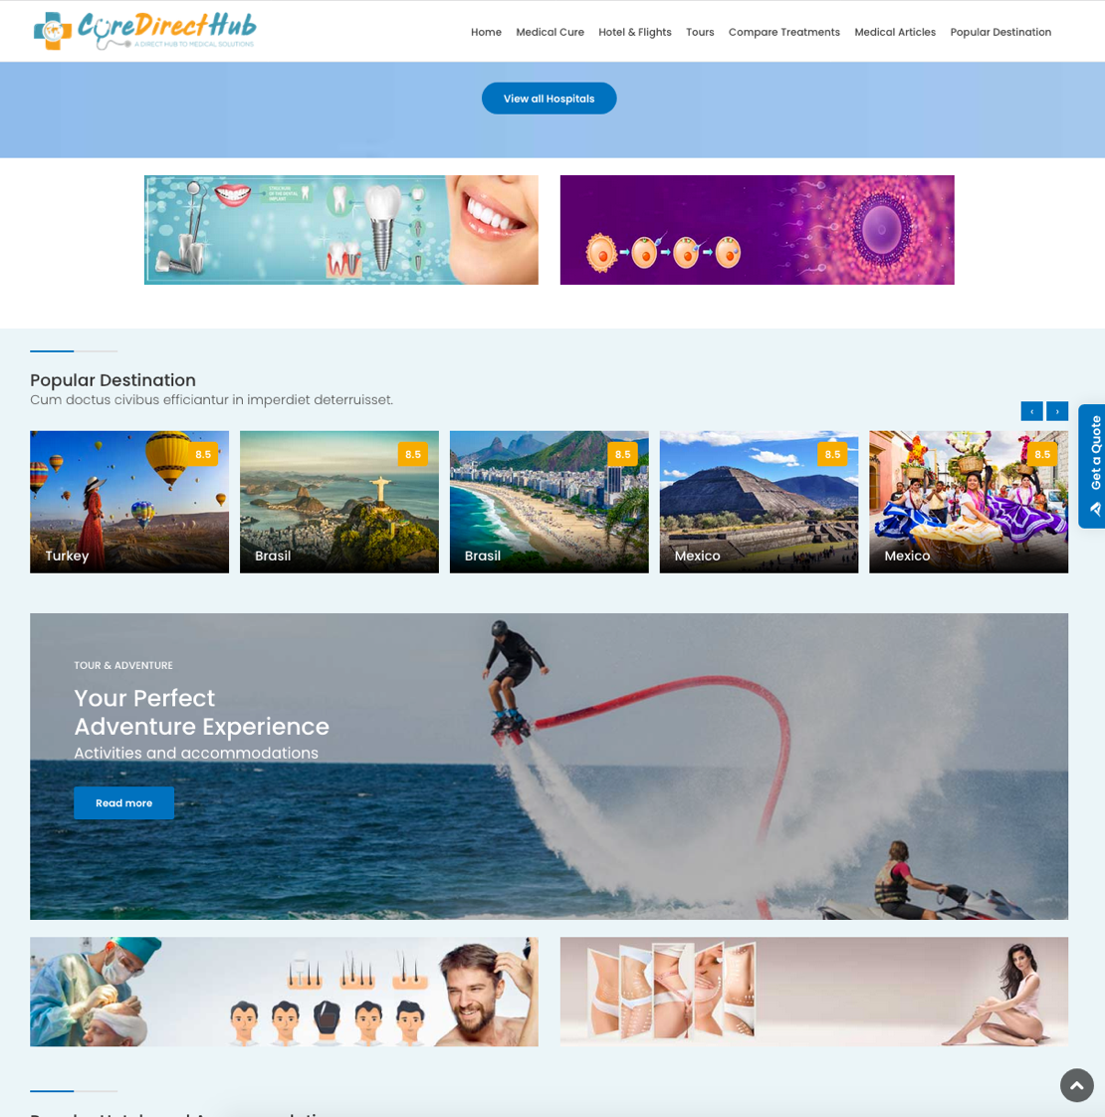

**Correction 16**

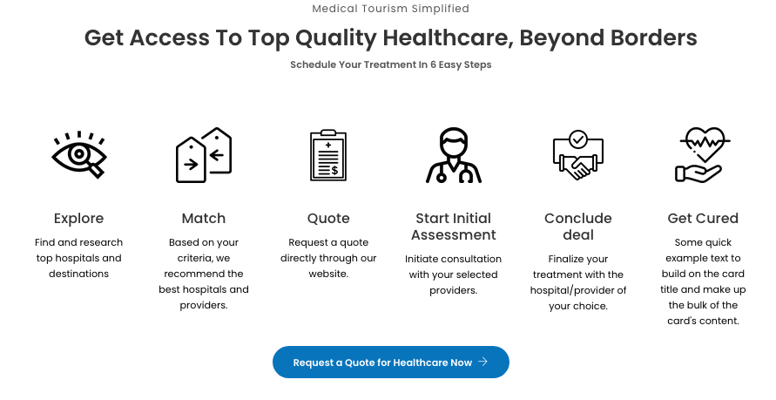

Click the word document for our new content for this page



**Correction 17**

Please keep below **all heading with same specification and keep centre alignment**

Font : Poppins Medium

Font size : 1.75 rem

line Height : 1.2

**Sub lines**

Font : Poppins Medium

Font size : 1.25 rem

line Height : 1.2

















**Correction 18**



Delete the top line





**Correction 19**

These 2 logos are not same size. Please make same size to other logos

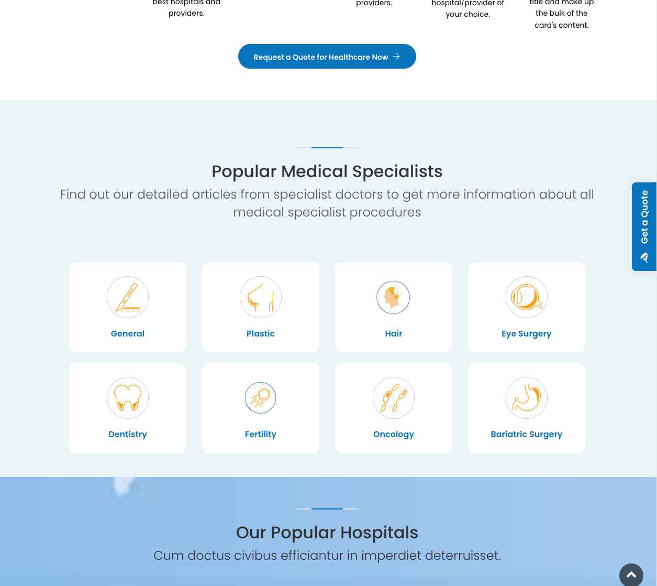

Please correct the title

1. Hair Transplant
2. General Surgery
3. Plastic Surgery

**Correction 20**



Wrong padding height

Correct padding height

I want to keep the same padding height **everywhere**. **Please check all the places** and do the corrections.

**Correction 21**



All descriptions in 2 lines. Same as I’ve written here

Fully accredited

hospitals

ç

We provide end-to-end medical tourism services under one roof.



Patient

support



Price Comparison

Fast Inquiry

Response

Get expert medical opinions for free

HIPAA Compliant Secure Data Sharing

Video Call Surgeon before Travel

**Correction 22**

I’ve asked this change before, when the request was made to remove the hotels picture and put the big generic images.

Please put the Popular Hotels and Accommodations after the Popular Destination and bring

the Tour and adventure (Swap the two images)

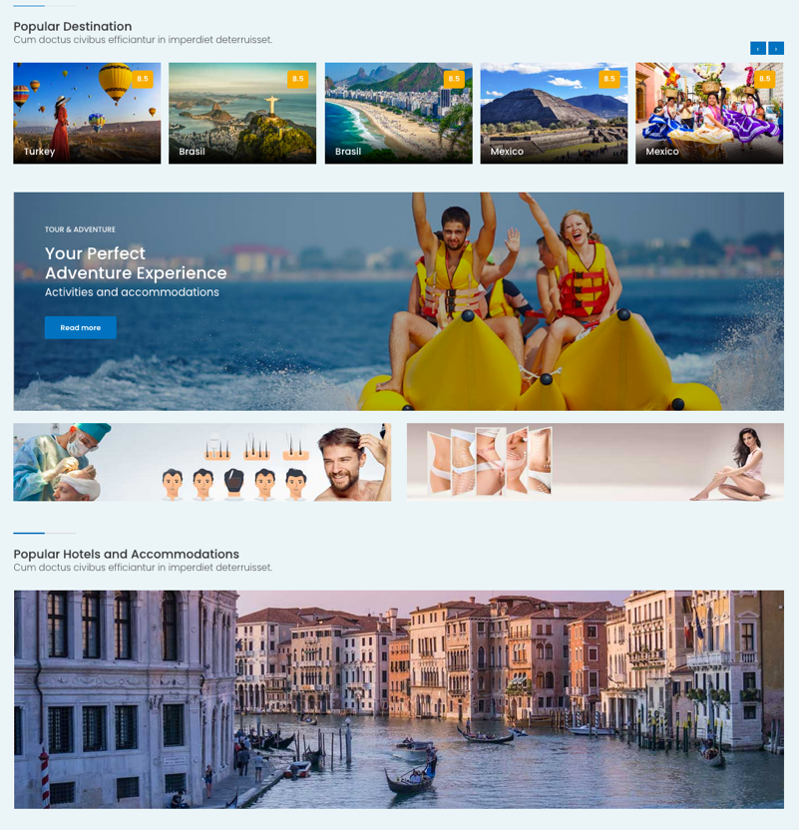

Please correct the title

BOOK WITH US TODAY

Save up to 60% on hotels and flights worldwide

One simple click to compare all the top travel sites



Please put the brand logo on top of all rotating images

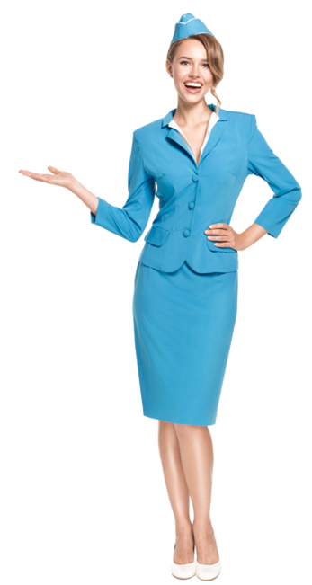IS IT POSSIBLE TO PUT THE BELOW Flight attendant Image on the TOP OF ALL ROTATING IMAGES??? This lady should stay on top of all changing images. Its LIKE 2 SPERATE LAYERS in Photoshop.  
CAN YOU ABLE TO DO THAT technically????

This part should look like below image

